**CH 245: ORGANIC CHEMISTRY 1 LABORATORY (Fall 2019)**

**Title:**

1. **Purpose: (1 point)**

The purpose of this experiment is to understand the method of measuring boiling point of a compound to determine the purity of a solid organic compound. This experiment will also introduce a new piece of lab equipment: the Mel-Temp.

1. **Drawing of structure of the main compound or balanced chemical equation if synthesis is performed: (1 point)**

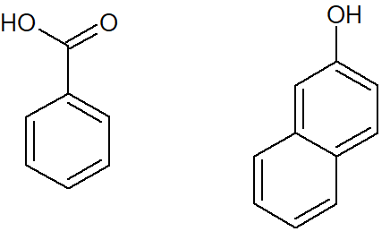

Benzoic Acid 2-Napthol

**3. Reagents and the major product (up to 6 points)**

|  |  |  |  |  |  |  |
| --- | --- | --- | --- | --- | --- | --- |
| **Name** | **M.W.**  (0.5 pts) | **Density**  (0.5 pts) | **Amount (grams/mL)**  (0.5 pts) | **Moles**  (0.5 pts) | **Hazards/Precautions**  **(MSDS data) and melting point or boiling point** (2 pts) | **Waste Disposal**  **(aqueous or organic)** (2 pts) |
| Benzoic Acid | 122.12 | 1.27 g/cm3 | N/A | N/A | Skin and severe eye irritation, M.P. 122.41 °C | Organic |
| 2-Napthol | 144.17 | 1.22 g/cm3 | N/A | N/A | May cause skin and eye irritation, M.P. 120-124 °C | Organic |

**4. Procedure (up to 2 points)**

|  |  |
| --- | --- |
| **Procedure** | **Observations and Lab Data** |
| A summary of the procedure done with bullet points) | Color changes, exothermic or endothermic reactions, gas generation, etc.; tare weights for flasks, etc. |
| * Prepare a powder sample of crystallized benzoic acid or other crystal mixture. * Place small amount of sample into capillary tube (1-3mm in length) by putting open end of tube into the powder, inverting the tube, and tapping powder to bottom of the tube. * Place tube and thermometer into Mel-Temp and turn on the heat. * Apply moderate heat and make a moderate approximation of the melting point. Record approximate temperature. * Prepare another sample in the same manner but heat slowly up to approximate melting point, around 15-20 degrees Celsius below. * Continue heating at 2 degrees Celsius per minute and record temperature when substance begins to melt. * Record temperature again when substance is completely melted. |  |

**5.** Results; include actual yield in grams and % yield.

|  |  |  |
| --- | --- | --- |
| **Sample (All Temperatures in °C)** | **Melting Point**  **(first run)** | **Melting Point**  **(second run)** |
| **Recrytallized Benzoic acid**  **(from Exp-1)** | **116-117** | **125-126** |
| **100% Benzoic acid (Pure)** | **114-124** | **125-128** |
| **100% 2-Naphthol (Pure)** | **113-116** | **120-124** |
| **90% Benzoic acid and 10% 2-Naphthol** | **111-121** | **110-122** |
| **50% Benzoic acid and 50% 2-Naphthol** | **109-117** | **93-110** |
| **10% Benzoic acid and 90% 2-Naphthol** | **88-99** | **92-112** |

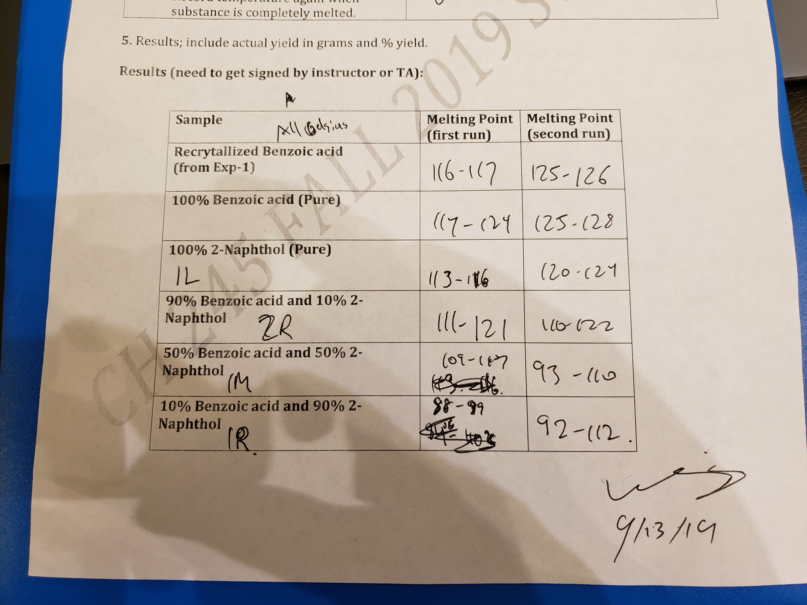

**6. Conclusion**

We **accomplished** a melting point determination for our recrystallized benzoic acid, as well as various mixtures of benzoic acid and 2-naphthol, including the pure substances themselves. We **learned** how to operate a Mel-Temp to observe both a rough estimation melting point and an exact melting point approximation. The **issue** we ran into was a much lower than expected value for most of the rough melting point tests, as well as a much lower than expected melting point for the 10% benzoic acid, 90% 2-naphthol sample. This was likely as a result of heating that was too strong, as well as a delay between the observation of melting and observation of the thermometer. In the **future**, crushing the sample into finer particles before putting it in the Mel-Temp might yield better results, as well as a more precise temperature measurement when melting is observed. The **practical application** for this experiment is the identification of an unknown solid, as well as identification of impurities in an unknown solid.

**7. Postlab Questions**

1. I could prove that is it benzoic acid and not 2-naphthol by mixing equal parts of the unknown and benzoic acid, and then conduct a melting point test on this mixture. If the melting point of the mixture drops, then the unknown is not pure benzoic acid, and it is 2-naphthol. If the melting point stays the same, then the unknown substance is benzoic acid.

2. An insoluble impurity will have no effect on the melting point of the benzoic acid.